* 5560803 SD Portal S SD Portal - Ensure user is able to update Maintenance (PSS).

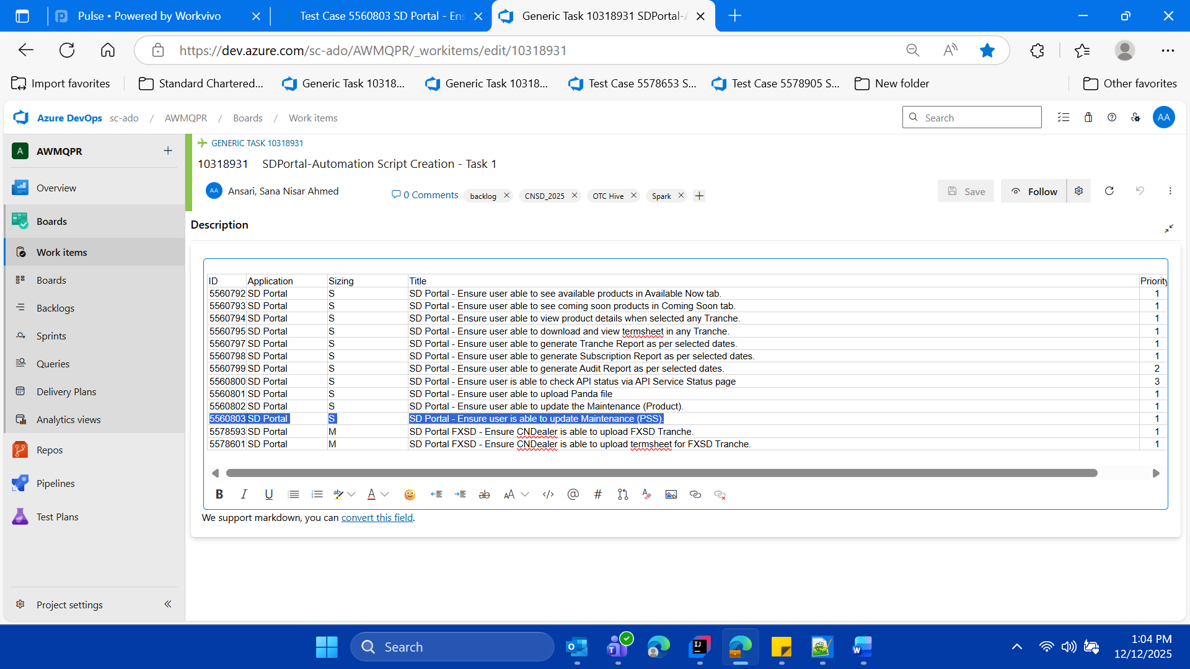

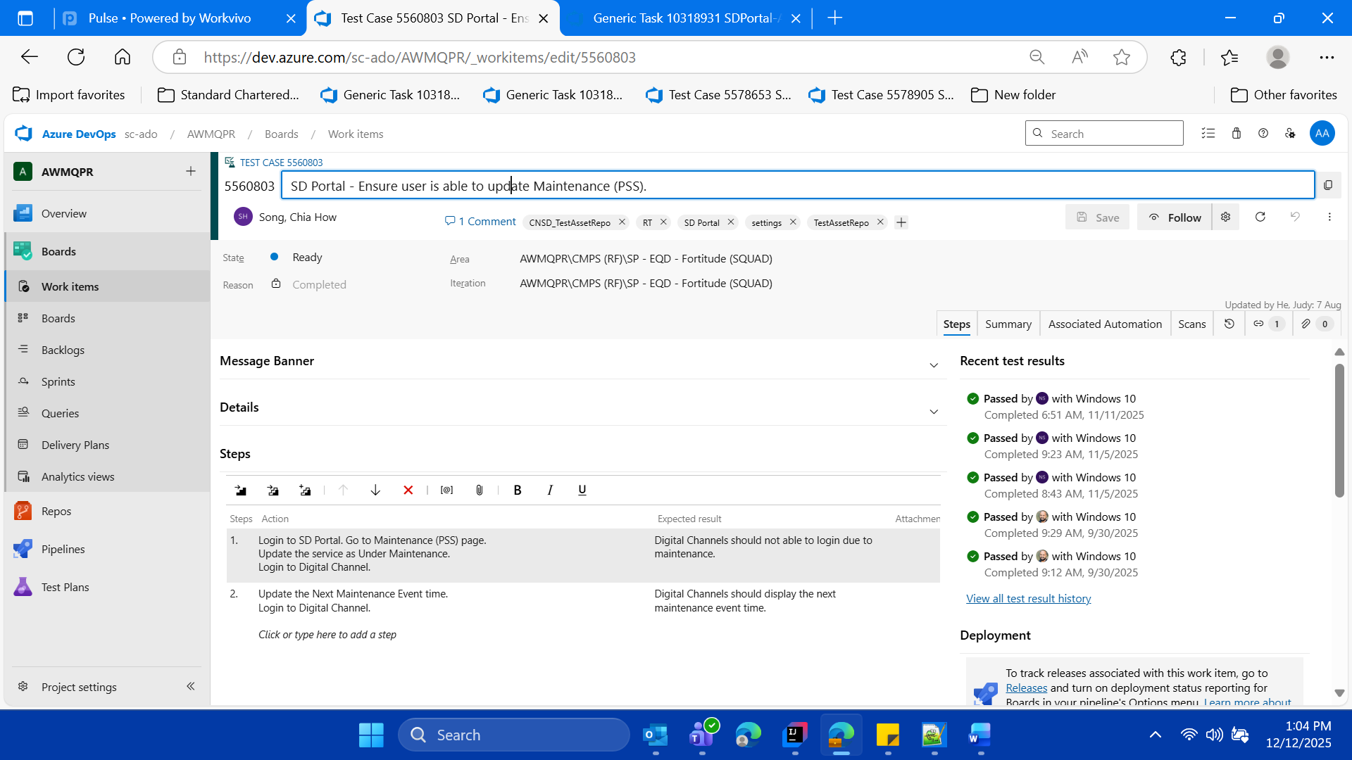



SDPortal New Dev URL

https://cnlvadeqc001.cn.standardchartered.com:8463/wm/full/cnsd/index2.html#/rmp/login

User ID-User Role For Maintenance (PSS) page update

For Maintainace (PSS)

1377543

Password (with LDAP)

SCBpassword5$

**==== For Maintainace (PSS) ---- ====**

**==== Note and update “Next Maintenance Event in SD Portal**

**” and convert the value back to original state in the SD Portal**

**Do verification of this action on the SSO MOCK Page**

**====**

Launch URL via already available background SD Portal (as per the login test case which is already implemented within the CNSD FW, so reuse but use this new id 1377543)

**login in SD Portal with User id** 1377543

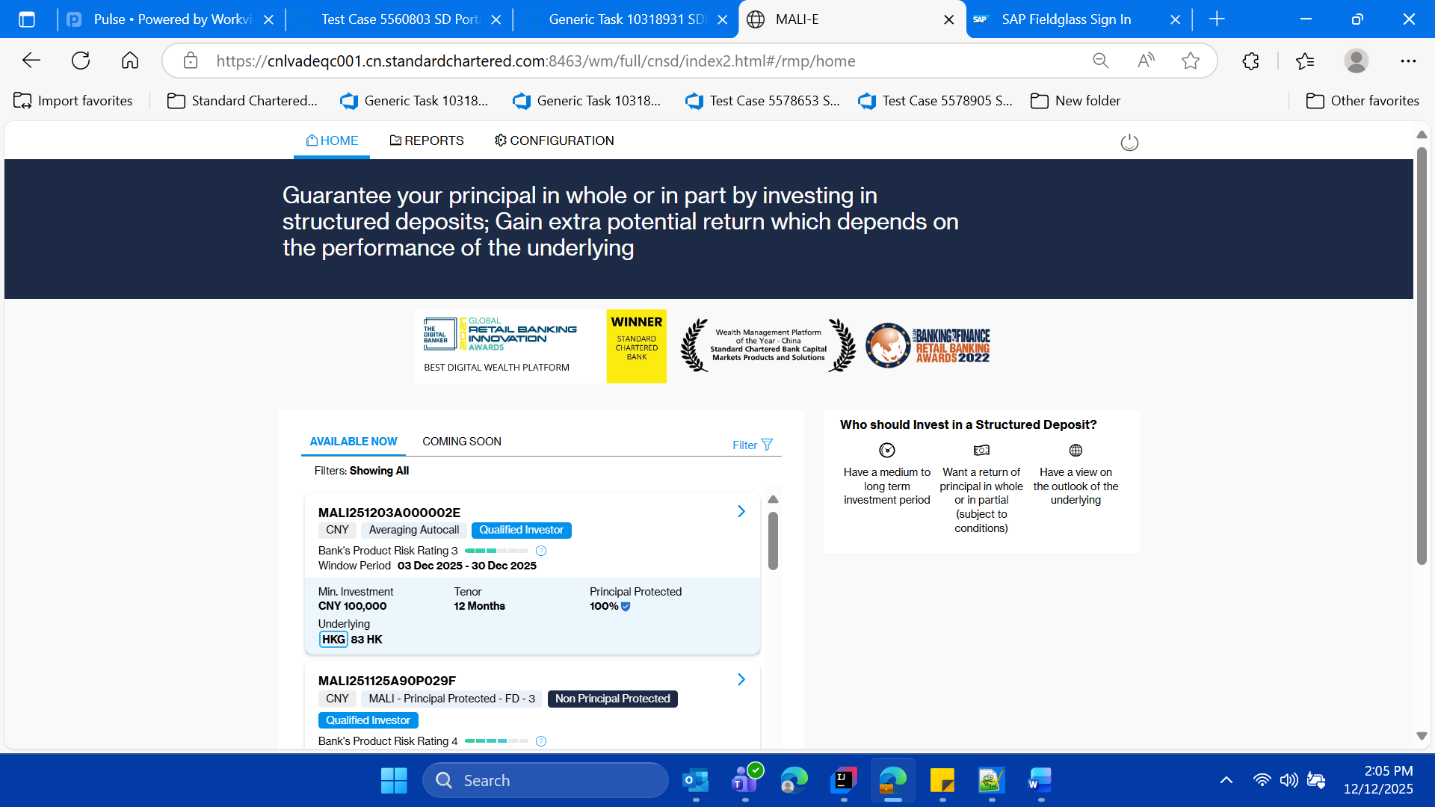

* **Click on the Configuration Tab/ and navigate to configuration page**

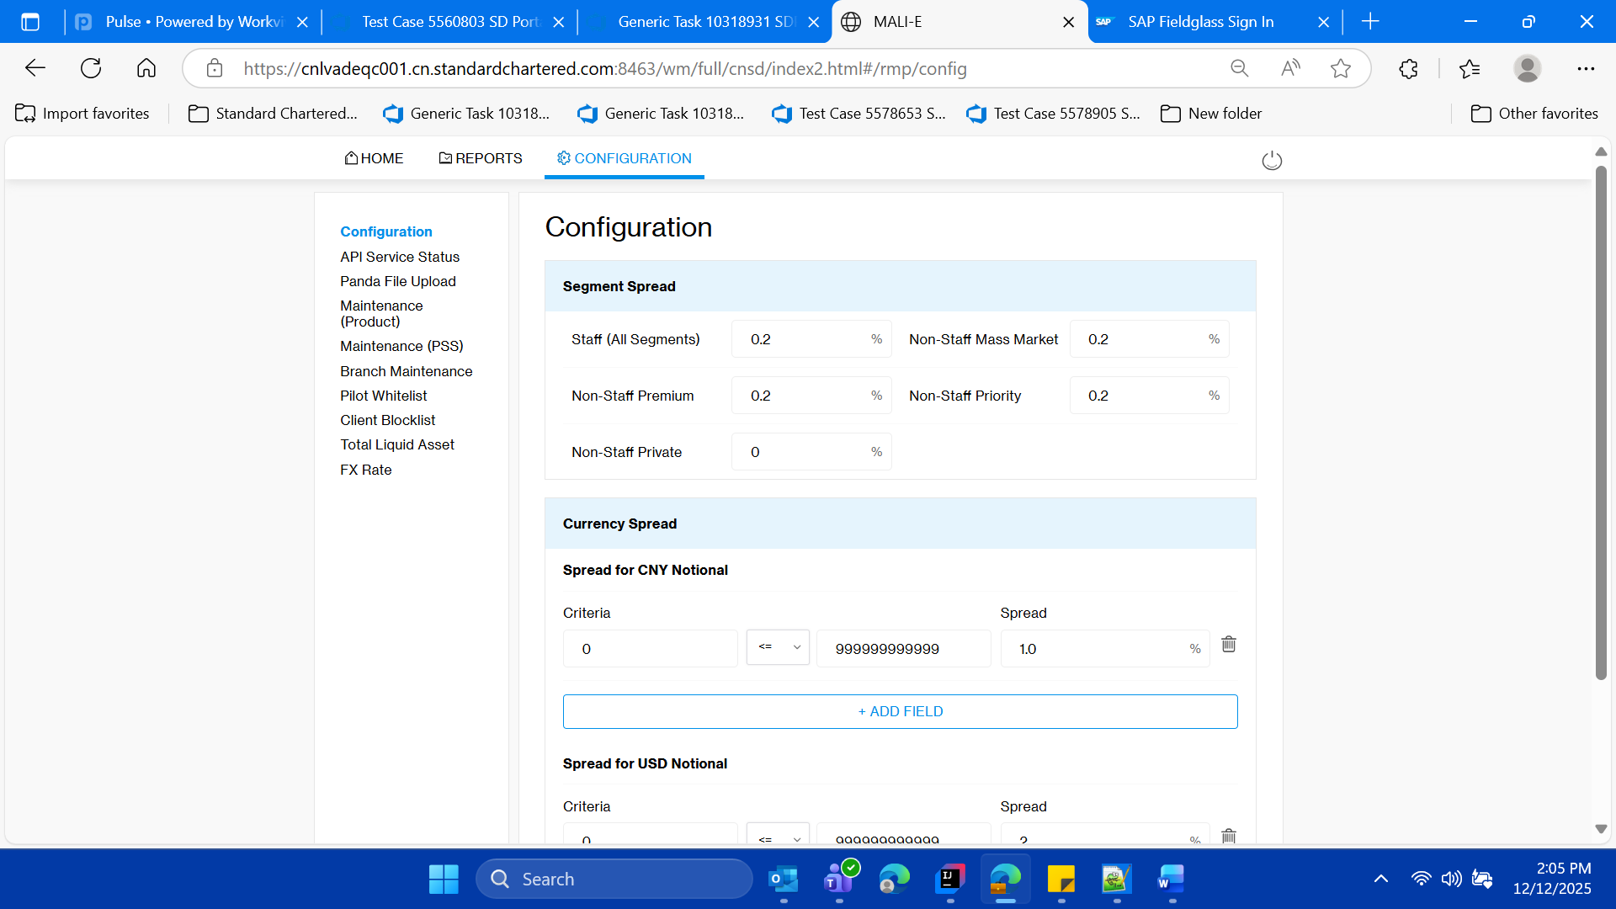

* **Click on the “Maintenance (PSS)” left menu and validate the tilte of the page as “Maintenance (Product)”**

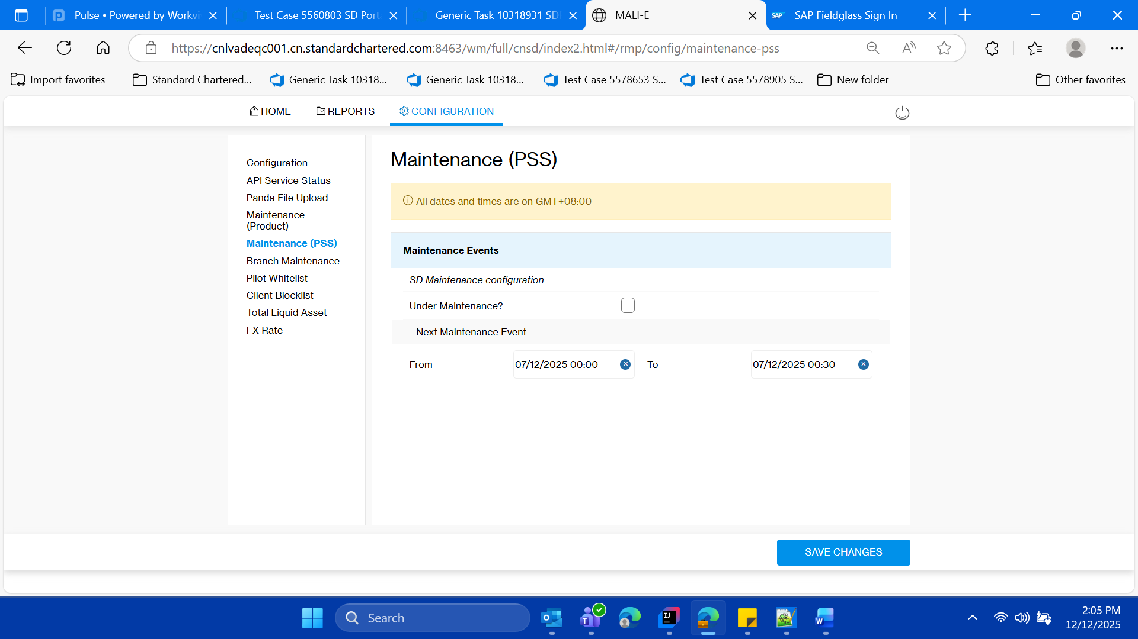

* **Within this “Maintenance Events” section of the page, keep the note of “From Date” and “TO Date” for current day of test case execution**



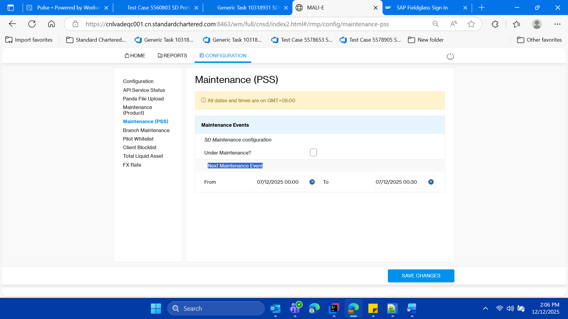

* **Now Update the Next Maintenance Event from and to date as per the current date and time , with small duration, for testing purpose.**
* **Click on cross icon for From date and time and update to new value**

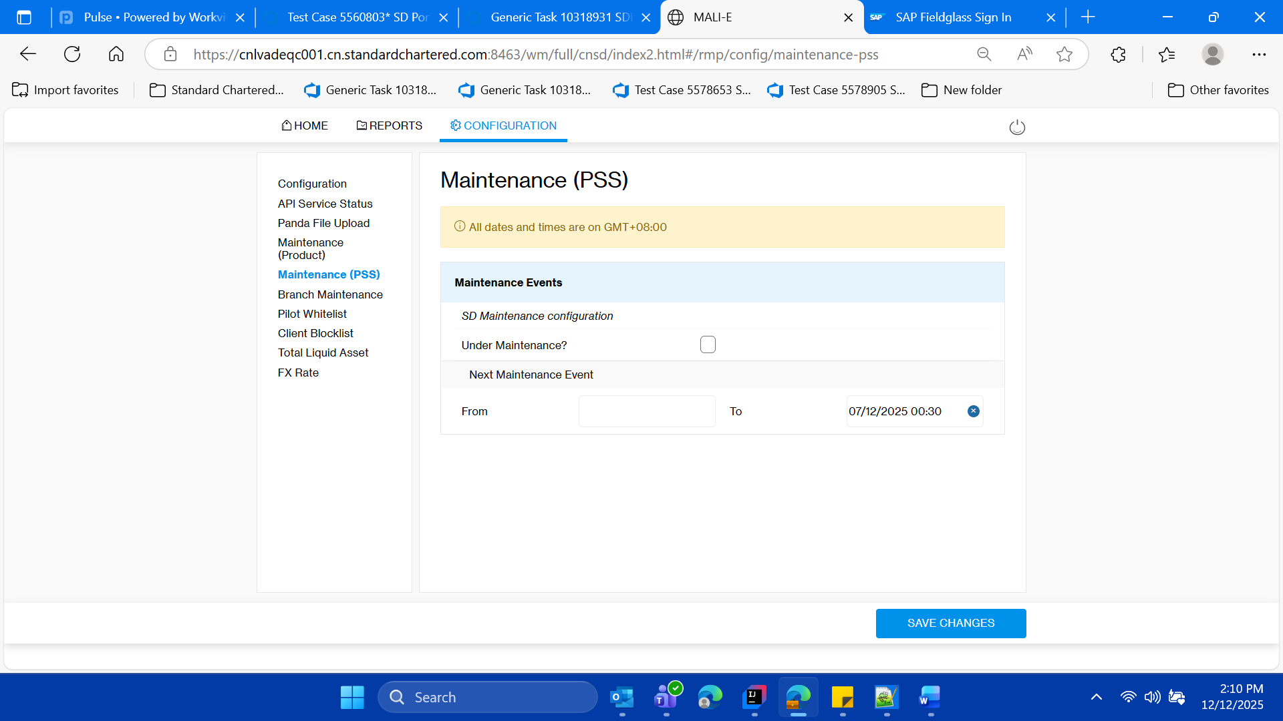

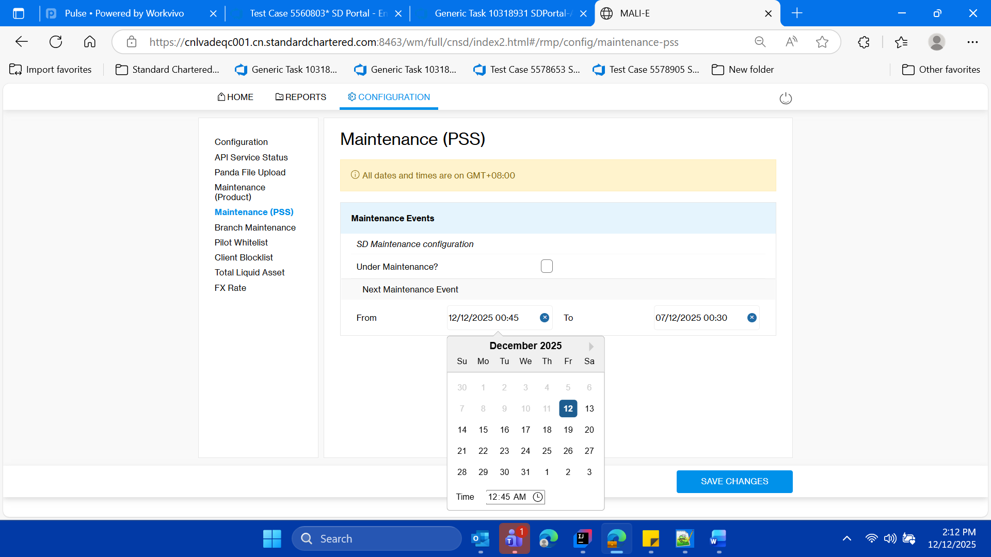

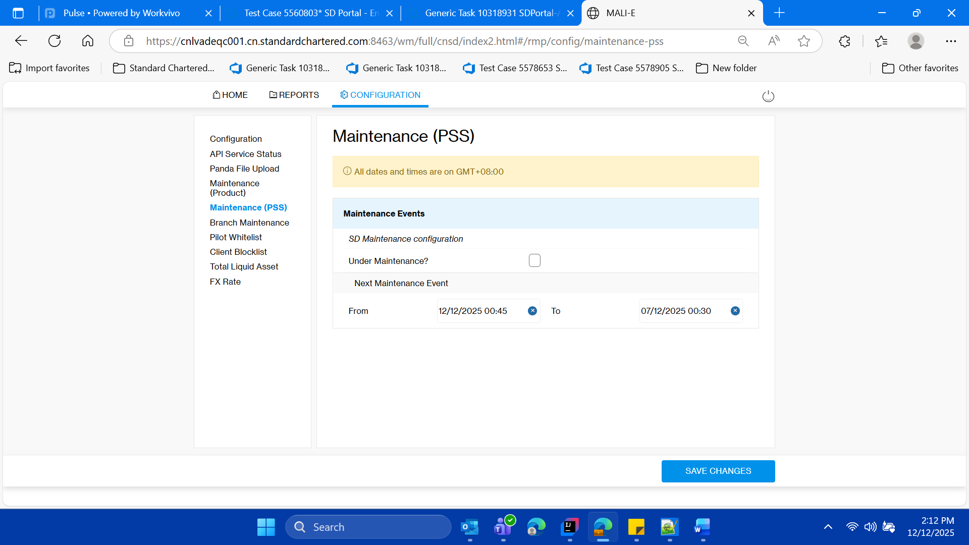

* **Click on cross icon for To date and time and update to new value**

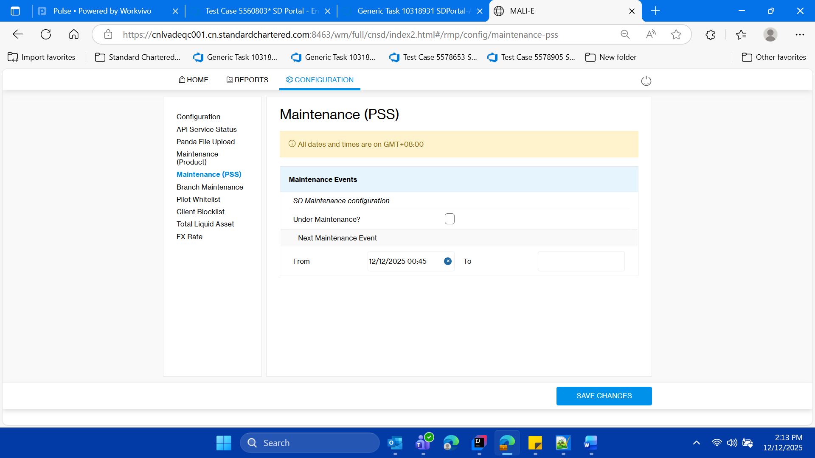

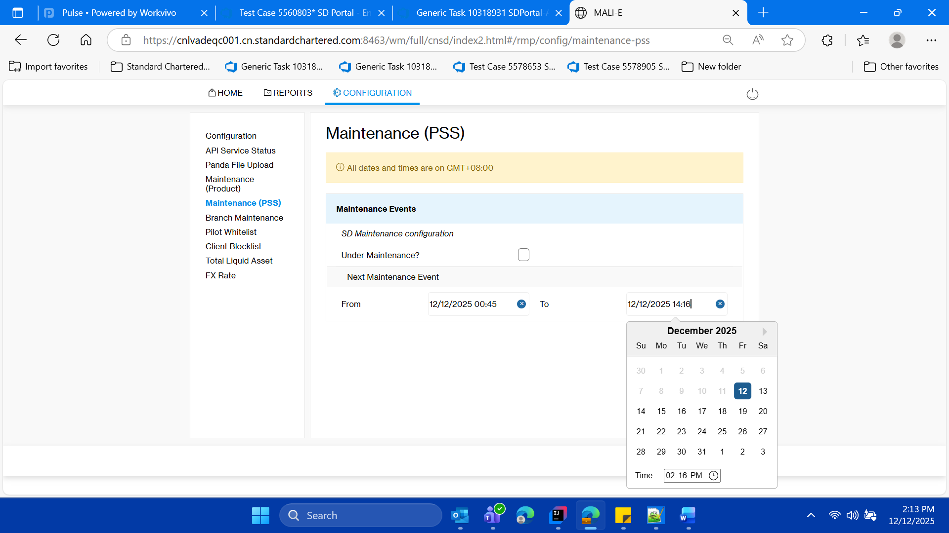

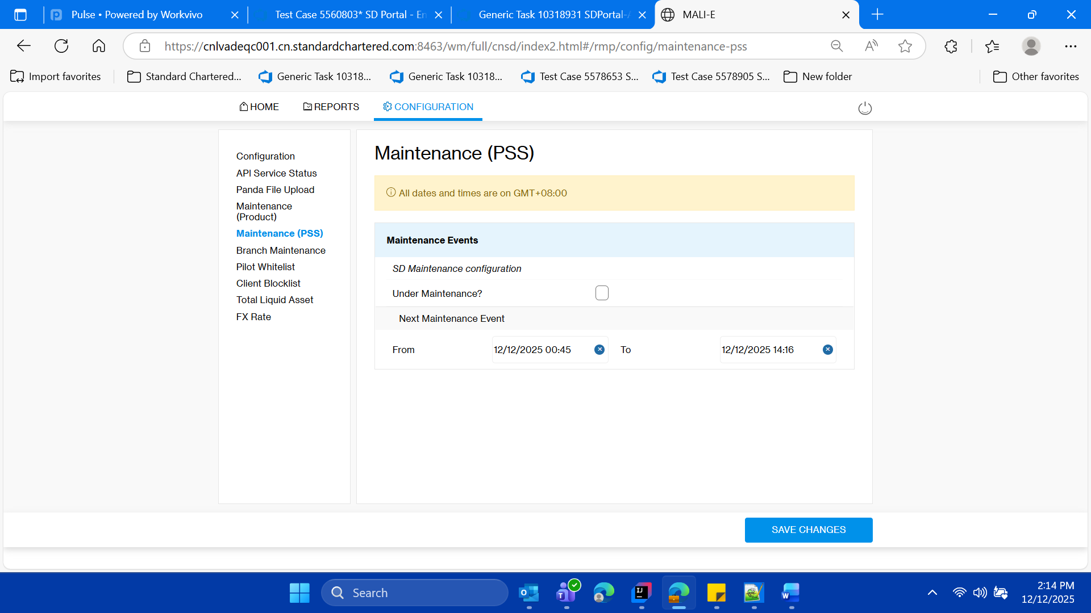

* **Click on save changes validate the success message**

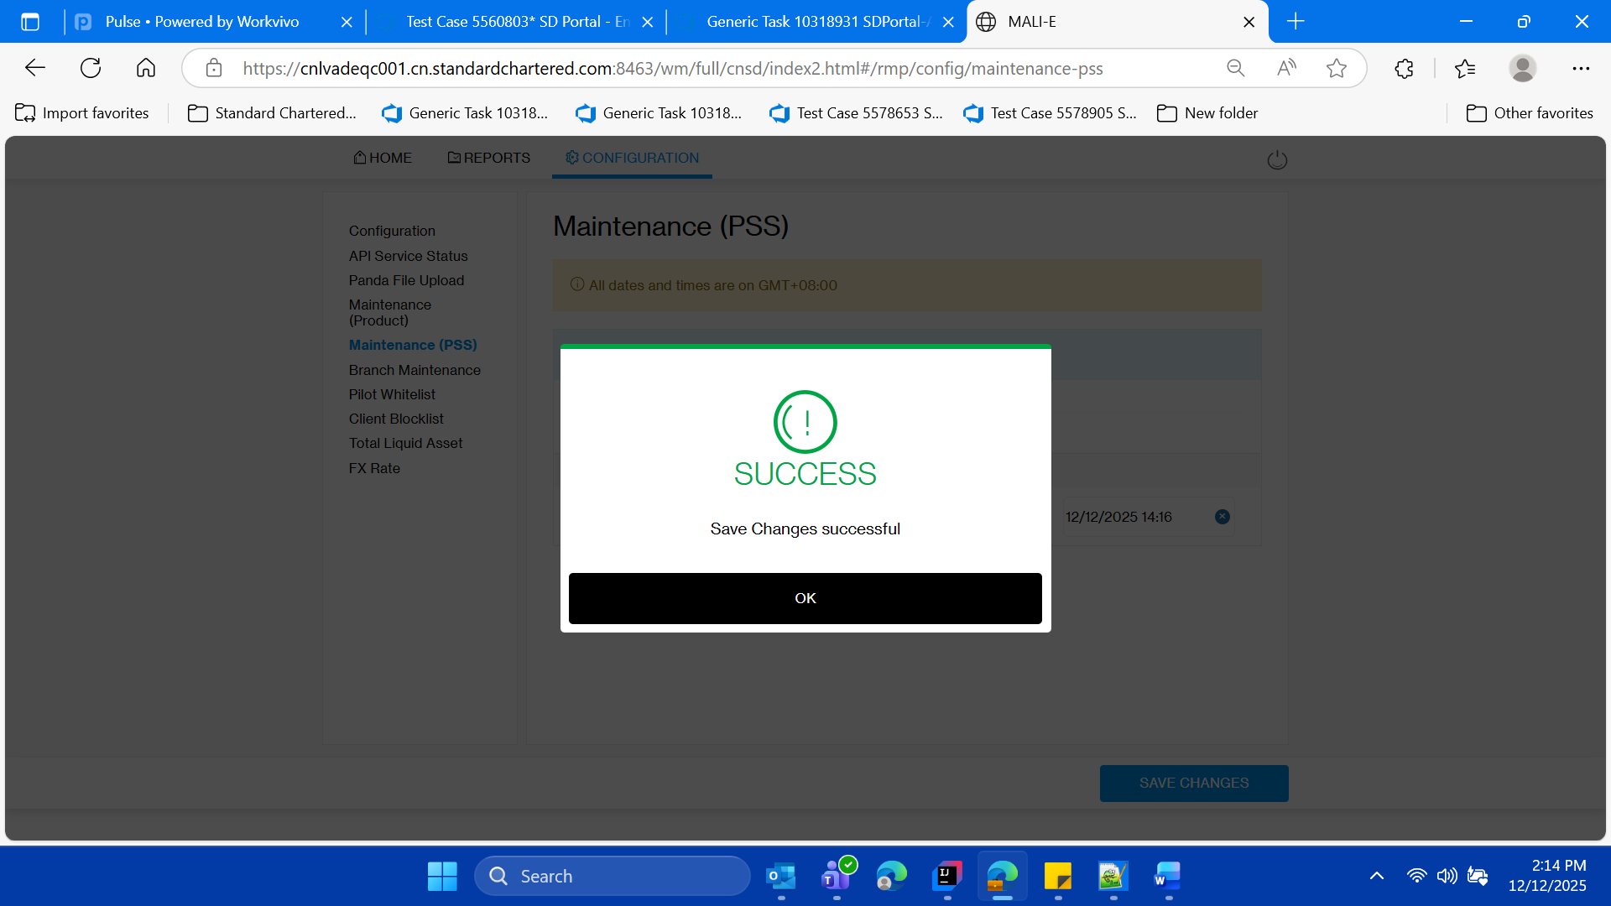

* **Click on ok button on save success message.**



* **Click on OK button**

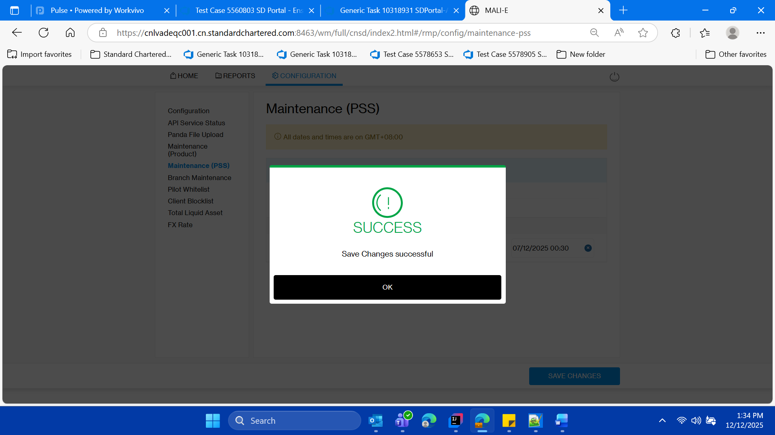



* **Validate the saved values**

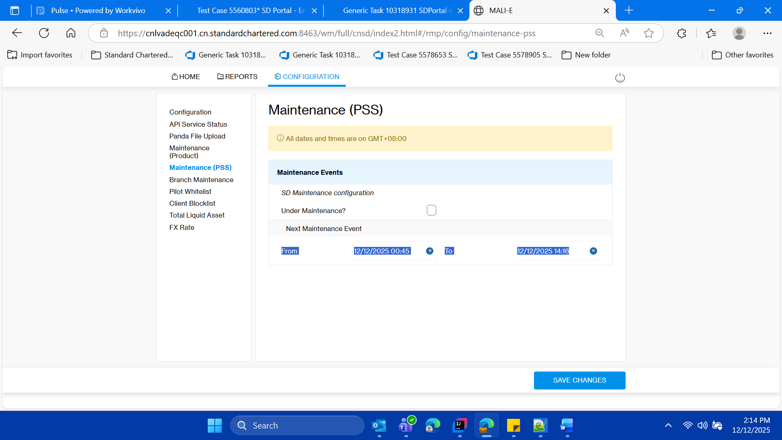

* **Login to SSO MOCK using Client id as 360297291**

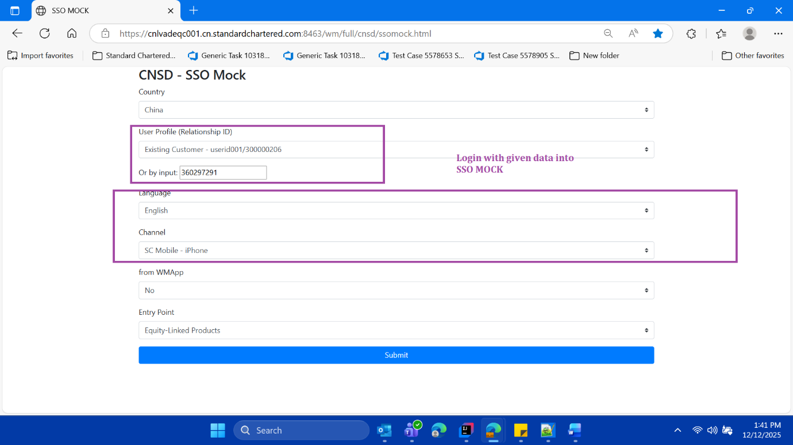

* **Click o submit button**



* **User should able to the see maintenance date and time on the top of the paroduct catalogue page of SSO MOCK**

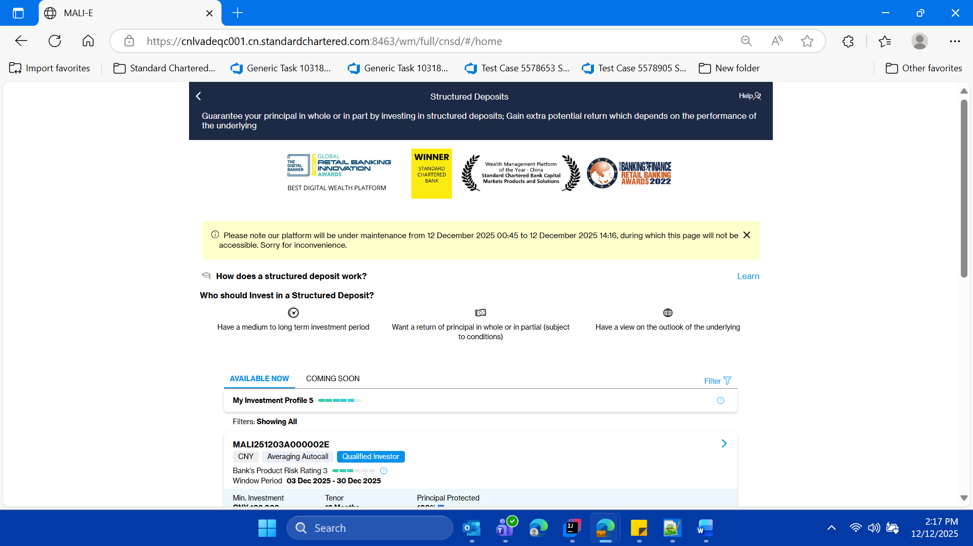

* **Validate the pop up with text on it**



* **Click on back button to logut of the application**

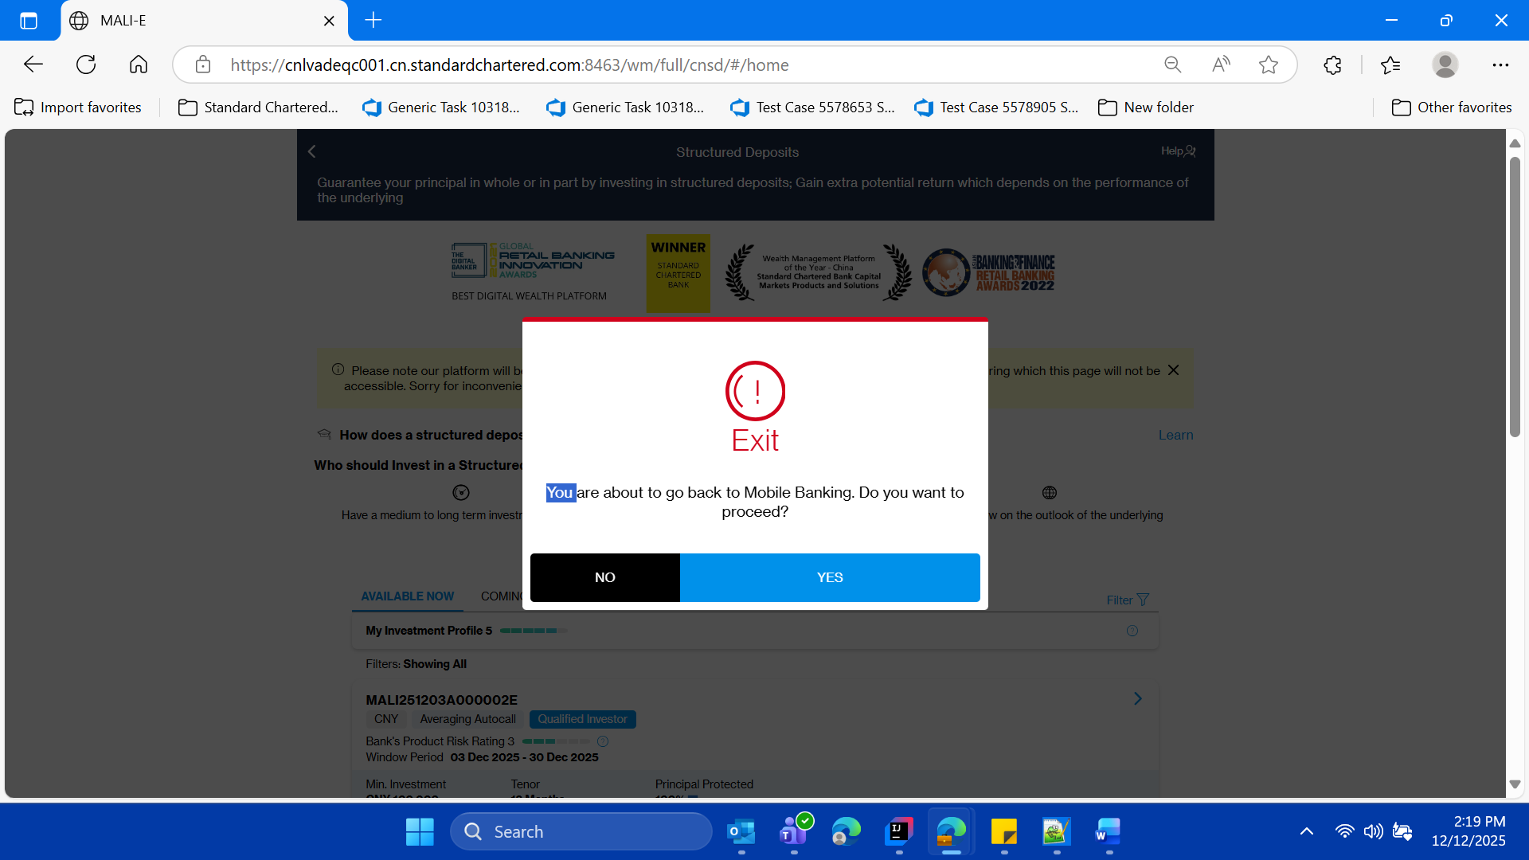

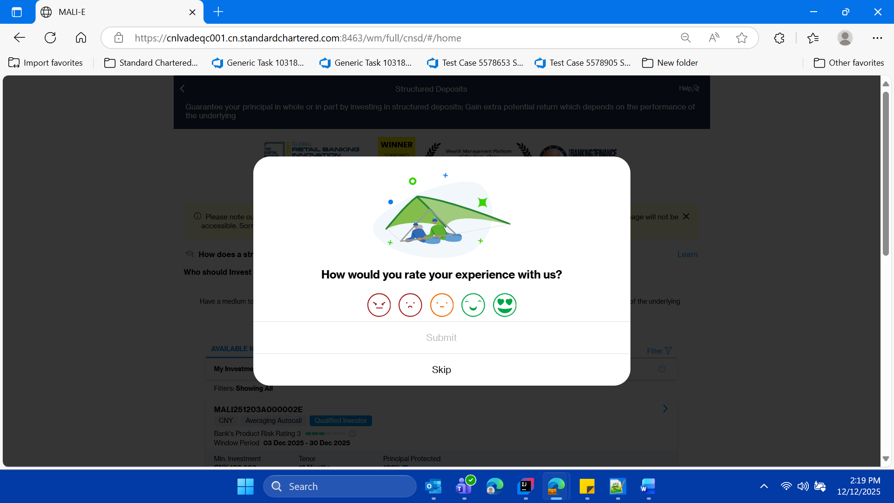

* **Now Click on the Skip button to close the pop up on in SSO mOck, validate user lands page of SSO MOCK**



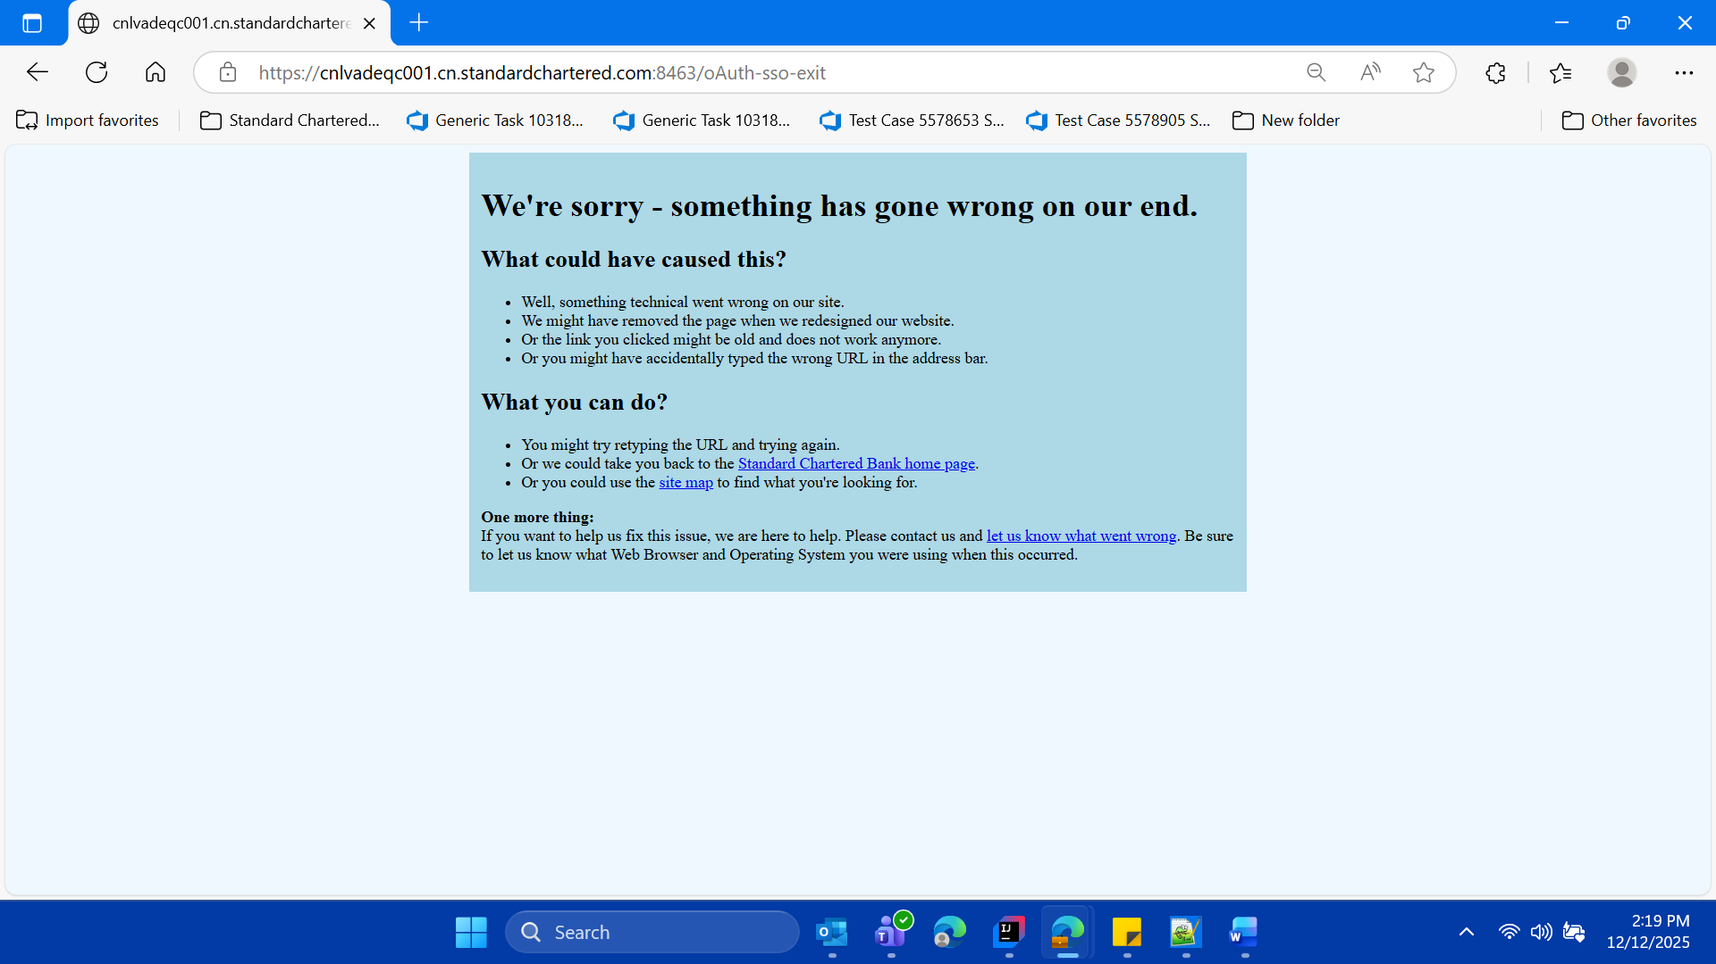

* **Now close this window**

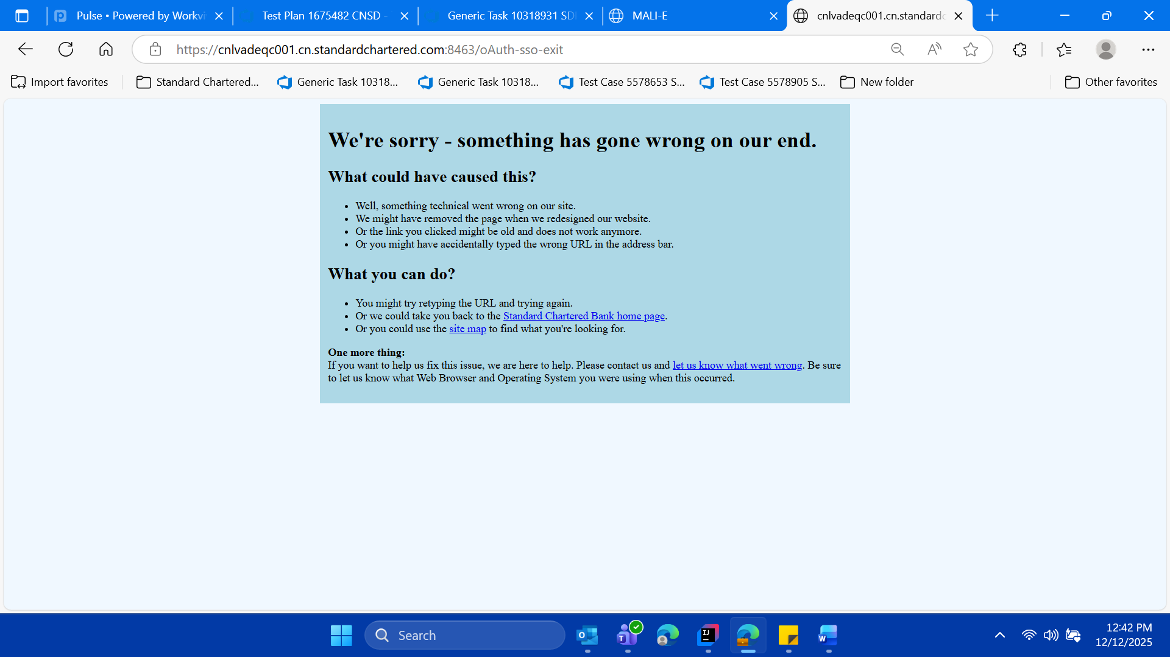

* **Now switch back on the SD Portal parent window , or login freshly into sd portal**

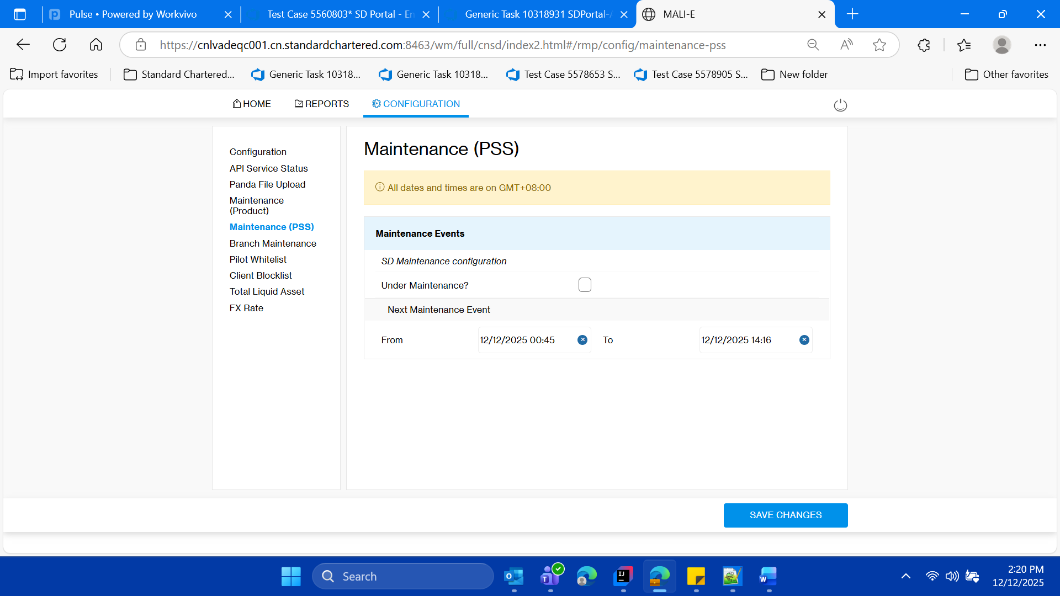

* **Change date and time to the original date and time**

**” in the format , it was there previously before the execution of this test case**

**-So basically converting the application the default state**

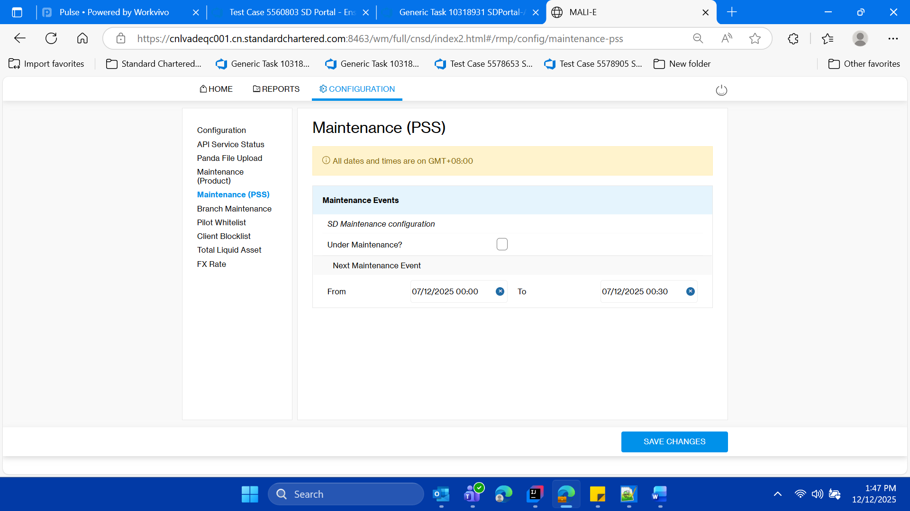

**Vliadate success message**

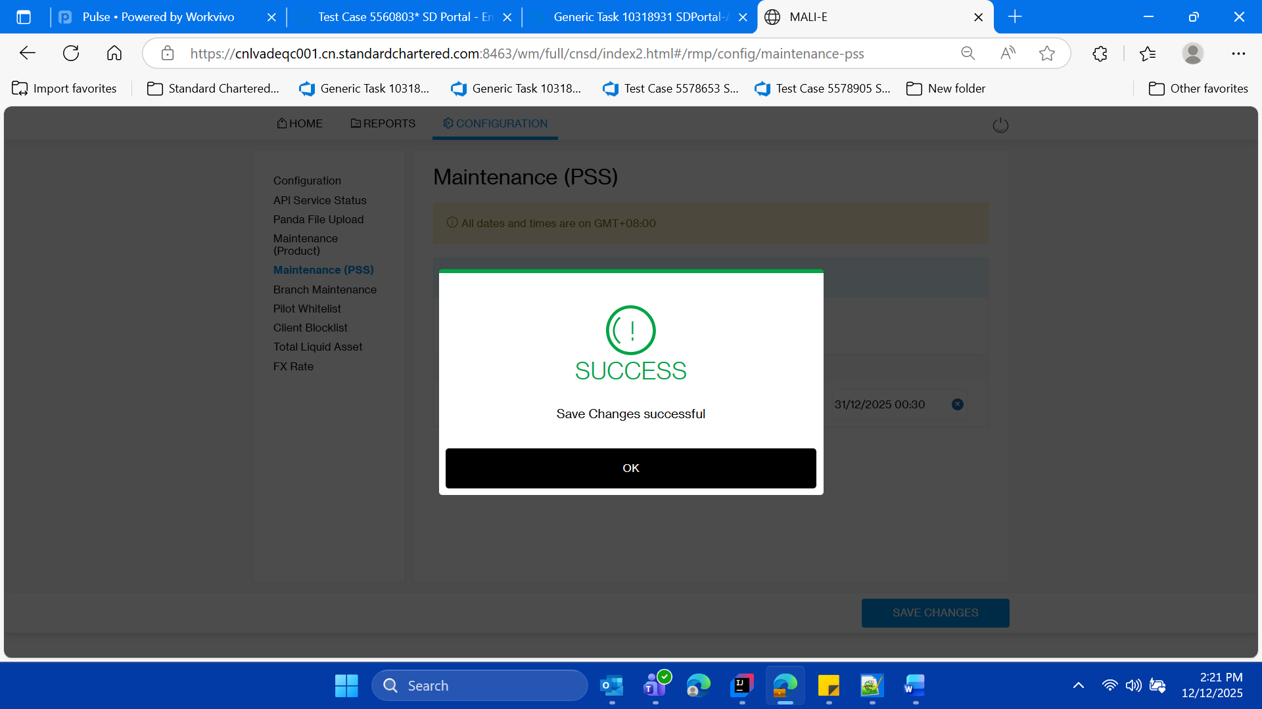

* **Click on ok button**

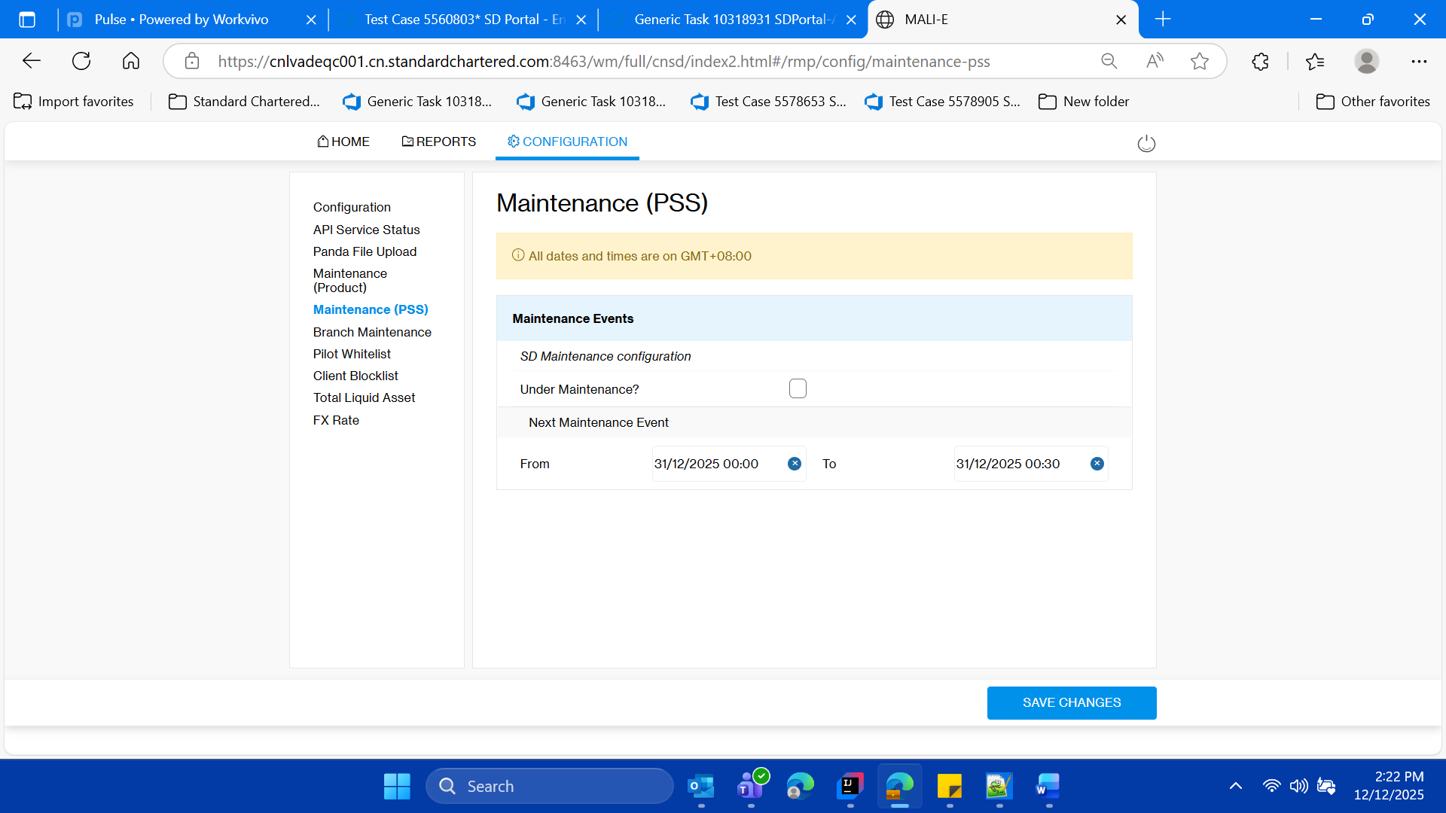

**Validate the the fields gets updated**

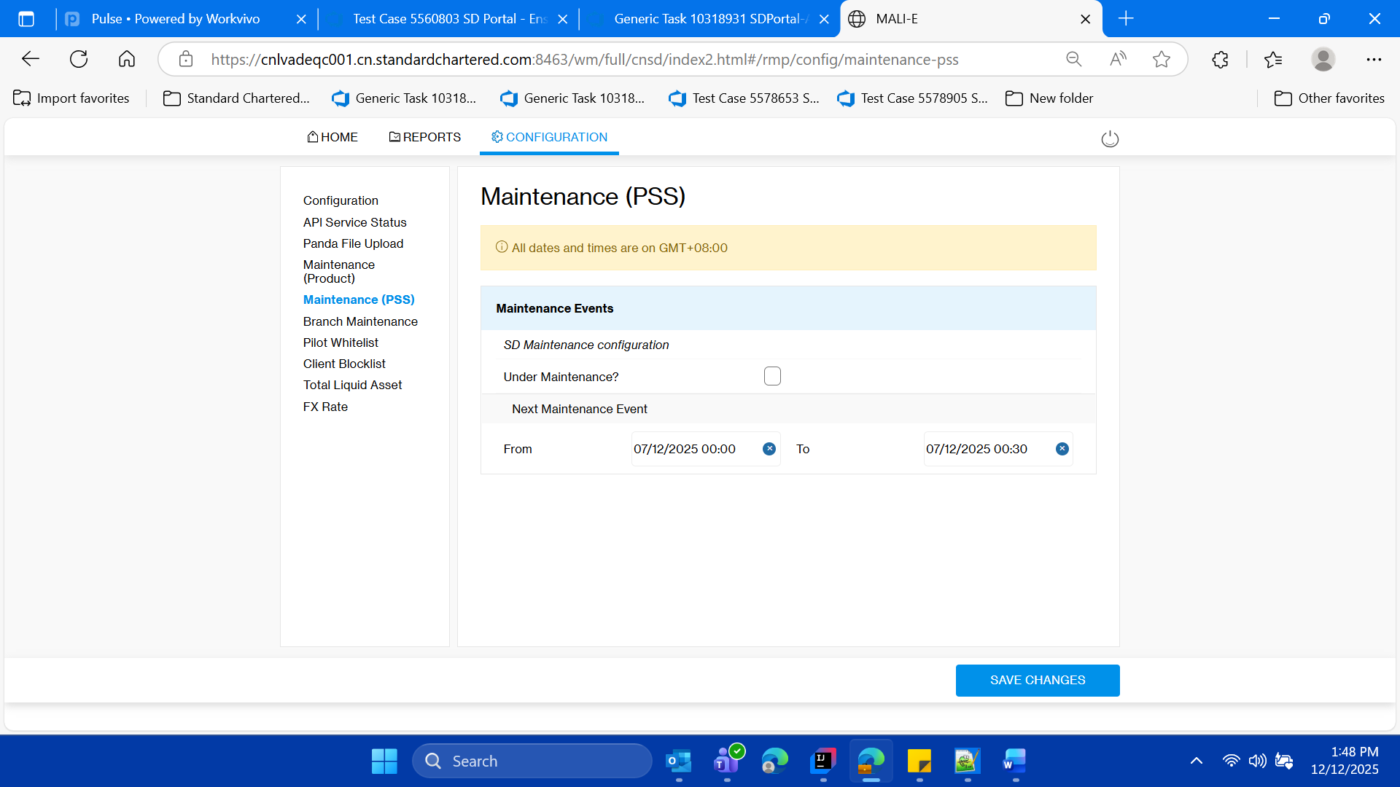

**-User shouldnot be able to select the past dates**

* **then logout of the SD Portal close the parent window of SD Portal**

